9.20: a) Equation (9.7) is solved for 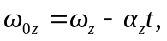which gives 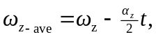 or 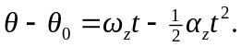 b) 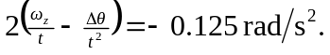 c) 